BLOGPOST - How to Split Equity Among Co-Founders

How to Split Equity Among Co-Founders
Founders often ask how they should split equity with their co-founders.
When I search the web on this topic I often see horrible advice, typically advocating for significant inequality among different founding team members. We see this trend reflected in the thousands of applications we review at Y Combinator every year.
Here are some of the most often cited reasons for unequal equity splits:
- I came up with the idea for the company
- I started working n months before my co-founder
- This is what we agreed to
- My co-founder took a salary for n months and I didn’t
- I started working full time n months before my co-founder
- I am older/more experienced than my co-founder
- I brought on my co-founder after raising n thousands of dollars
- I brought on my co-founder after launching my MVP
- We need someone to tie-break in the case of founder arguments
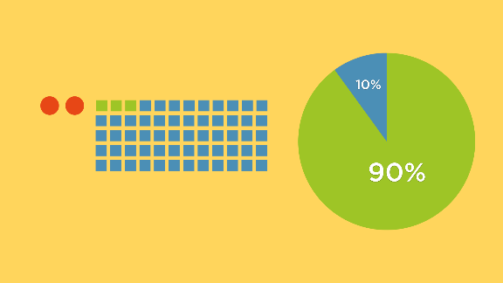

Founders tend to make the mistake of splitting equity based on early work.
All of these lines of reasoning screw up in four fundamental ways:
- It takes 7 to 10 years to build a company of great value. Small variations in year one do not justify massively different founder equity splits in year 2-10.
- More equity = more motivation. Almost all startups fail. The more motivated the founders, the higher the chance of success. Getting a larger piece of the equity pie is worth nothing if the lack of motivation on your founding team leads to failure.
- If you don’t value your co-founders, neither will anyone else. Investors look at founder equity split as a cue on how the CEO values his/her co-founders. If you only give a co-founder 10% or 1%, others will either think they aren’t very good or aren’t going to be very impactful in your business. The quality of the team is often one of the top reasons reason why an investor will or won’t invest. Why communicate to investors that you have a team that you don’t highly value?
- Startups are about execution, not about ideas. Dramatically unequal founder equity splits often give undue preference to the co-founder who initially came up with the idea for the startup, as opposed to the small group founders who got the product to market and generated the initial traction.


Equity should be split equally because all the work is ahead of you.
My advice for splitting equity is probably controversial, but it’s what we have done for all of my startups, and what we almost always recommend at YC: equal equity splits among co-founders. [1] These are the people you are going to war with. You will spend more time with these people than you will with most family members. These are the people who will help you decide the most important questions in your company. Finally, these are the people you will celebrate with when you succeed.
I believe equal or close to equal equity splits among founding teams should become standard. If you aren’t willing to give your partner an equal share, then perhaps you are choosing the wrong partner.
Thank you to Justin Kan, Qasar Younis, and Colleen Taylor for reading drafts of this essay
Notes:
[1] If you fear what will happen if you have to break up with a co-founder, make sure you have a proper vesting schedule. In the Valley, a typical setup is to have four years of vesting with a one year “cliff.” In other words, while you might own 50% of the company on paper, if you leave or get fired within a year you walk away with nothing. After the one year point you get 25% of your stock. Every month after that you get an additional 1/48th of your total stock. You only earn all of your stock at the end of four years. This ensures that founders are a good fit for the long haul — and if there is a problem you can fix it without harm in year one. Another good contingency measure is for only the CEO to hold a board seat before a significant equity fundraise. That will prevent board disputes during tough decisions, such as in the unlikely event that the CEO has to fire a co-founder.

Aus <http://blog.ycombinator.com/splitting-equity-among-founders/>

